**Flow Control Statements**

**1] for statements**

#include<iostream.h>

#include<conio.h>

void main()

{

int i;

clrscr();

cout<<"For statements...."<<endl;

for(i=1;i<5;i++)

{

cout<<endl<<i;

}

getch();

}

Output:

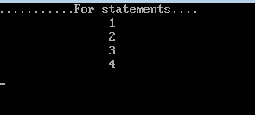

**2] While statements:**

#include<iostream.h>

#include<conio.h>

void main()

{

int i=1;

clrscr();

cout<<"....While Statements....."<<endl;

while(i<8)

{

cout<<endl<<"\t\t"<<i;

i++;

}

getch();

}

Output:

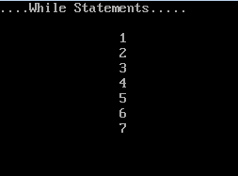

**3]IF statements:**

#include<iostream.h>

#include<conio.h>

void main()

{

int i=8,a=12;

clrscr();

cout<<"....IF Statements....."<<endl;

if(i<10)

{

cout<<endl<<"... 8 is less than 10";

}

getch();

}

Output:

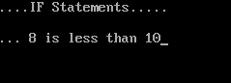

**4]Else statements:**

#include<iostream.h>

#include<conio.h>

void main()

{

clrscr();

int age;

cout<<"\n\t Enter the Numbers:"<<endl;

cin>>age;

if(age<18)

{

cout<<"You are child"<<endl;

}

else

{

cout<<"You are young"<<endl;

}

getch();

}

Output:

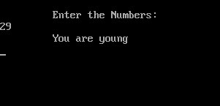

**5]Switch statements:**

#include<iostream.h>

#include<conio.h>

void main()

{ int ch;

clrscr();

cout<<"\t Enter any number... (1 to 4)"<<endl;

cin>>ch;

switch(ch)

{

case 1:

cout<<"\t\n Today is Monday"<<endl;

break;

case 2:

cout<<"\t\n Today is Tuesday"<<endl;

break;

case 3:

cout<<"\t\n Today is Wednesday"<<endl;

break;

case 4:

cout<<"\t\n Today is Thursday"<<endl;

break;

default:

cout<<"\t\n Only Enter value 1 to 4"<<endl;

}

getch();

}

Output:

